**The 7 Stages of Game Development**

October 15, 2019

**by** [**Devin Pickell**](https://learn.g2.com/author/devin-pickell)



**Share**

Most people who design and build video games for a living will tell you that game development is never as pretty as planned.

Impending deadlines, bottlenecks in production, pressure from [video game publishers](https://learn.g2.com/video-game-publishers), and endless work-weeks are just a few of the many challenges that arise during the development cycle.

However, the brave few that go into game development are aware of the culture and its habit of testing one’s grit and determination, but the drive to produce video games that look, feel, and play beautifully is what keeps them going.

Many aren’t aware of this cycle of madness and its many stages, so I’m here to shed some light on game development.

**7 stages of game development**

While video game development is chaotic in nature, there are still structures and frameworks in place to keep studios running efficiently and projects on track to be completed. The stages of game development go as followed:

**What are the stages of game development?**

1. Planning
2. Pre-production
3. Production
4. Testing
5. Pre-launch
6. Launch
7. Post-production

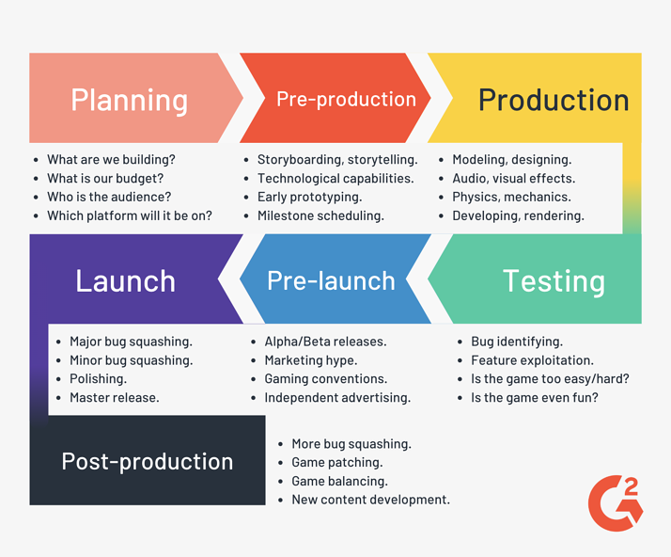

**1. Planning a video game**

Before the writers begin writing, the designers begin designing, and the developers begin developing, an idea for a video game has to surface. This is the very first part of the planning stage and the roots that every video game will grow from.

In the planning stage, the most basic questions will need to be answered, like:

* What type of video game are we producing?
* Will it be 2D or 3D?
* What are some of the key features it *must* have?
* Who are its characters?
* When and where does it take place?
* Who is our target audience?
* Which platform are we building this on?

It may not seem like it, but ideating a video game is one of the hardest parts of game development. The idea a gaming studio comes up with will serve as the backbone of the entire game. It’s what sets the standard for every employee involved with building the game, but also gives publishers a high-level overview of what to expect. This brings us to the next part of development – proofing a concept.

A proof of concept takes all the ideas that have been generated and sees how viable they are for the gaming studio to produce. From there, additional questions will need to be answered, like:

* What is our estimated cost to develop this game?
* Do we have the technological capabilities to build it?
* Will we require a new gaming engine?
* How big will our team need to be?
* Are we hiring external voice actors and writers?
* What is our estimated timeframe for launch?
* How are we monetizing it? **Hint:** [Loot boxes](https://learn.g2.com/loot-boxes) are probably not the best way.

For studios that are building a game under the umbrella of a publisher, proofing a concept is required before moving forward with pre-production and may even require a vertical slice. This is because the publisher will have to approve a pitch for time, budget, and marketing.

For independent studios without publisher oversight, there is a bit more flexibility during this phase. The downside to independent publishing is establishing a development and marketing budget, although, [crowdfunding](https://learn.g2.com/crowdfunding) websites like Kickstarter and Fig come in handy. As a matter of fact, successful games like *Pillars of Eternity* and *Shovel Knight* were completely crowdfunded.

Whichever route you take, a proof of concept is vital to the success of a game because it puts ideas in the perspective of what is capable. Now it’s time to begin pre-production.

**2. Pre-production**

The next stage of game development, called pre-production, brainstorms how to give life to the many ideas laid out in the planning phase. This is where writers, artists, designers, developers, engineers, project leads, and other crucial departments collaborate on the scope of the video game and where each piece of the puzzle fits. A few examples of this collaboration may look like:

* Writers meeting with the project leads to flesh out the narrative of the story. Who are the main characters in this tale? What are their backstories? How does each character relate to one another? Are there loose ends we’ll need to tie up later?
* Engineers meeting with writers, letting them know that under the current technological constraints, we can’t fill *that* environment with 100 characters or the game will crash.
* Artists meeting with designers to ensure visuals, color palettes, and art styles are consistent and aligned with what was laid out in the planning phase.
* Developers meeting with engineers to flesh out all the in-game mechanics, physics, and how objects will render on a player’s screen.
* Project leads meeting with multiple departments to figure out the “fun factor,” which you’ll find out later isn’t easy to pinpoint until the testing stage.

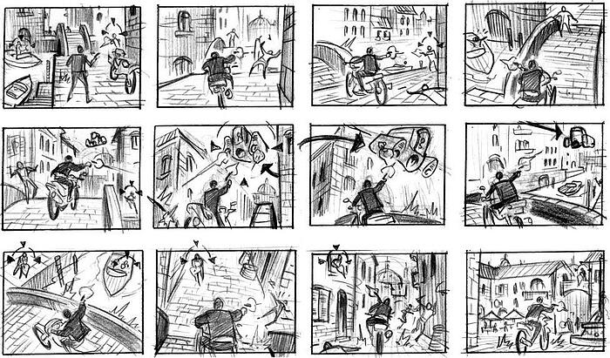

From here, it’s common for studios to prototype characters, environments, interfaces, control schemes, and other in-game elements to see how they look, feel, and interact with one another. This is essentially the “let’s see what we’re working with” moment before moving onto the bread-and-butter of development – production.

**3. Production**

Most of the time, effort, and resources spent on developing video games are during the production stage. This also happens to be one of the most challenging stages of video game development. During this process:

* Character models are designed, rendered, and iterated on to look exactly how they should in the story.
* Audio design works tirelessly to ensure every time your character steps onto sand, gravel, or cement, it sounds authentic.
* Level designers craft environments that are dynamic, immersive, and suitable for many types of playstyles.
* Voice actors read large stacks of scripts, doing take after take to get the right emotion, timing, and tone.
* Developers write thousands-of-lines-of-source code to bring each piece of in-game content to life.
* Project leads establish milestones and sprint schedules, ensuring each department and its team members are held accountable. This is especially important if a publisher regularly checks in for status updates.

These events and many more could take years of iterating to get right, and that’s assuming only a few changes are made along the way, which is hardly the reality.

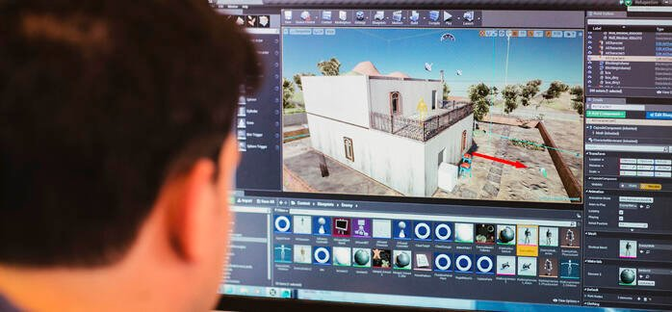

*Source: Worcester Polytechnic Institute*

In video game development, it’s not uncommon for entire segments of a game – months worth of work – to get scrapped after it's completed. You can imagine how frustrating this is for the employees involved. These types of changes are typically brought up in the testing stage.

**4. Testing**

Every feature and mechanic in the game needs to be tested for quality control. A game that hasn’t been thoroughly tested is a game that’s not even ready for an Alpha release. Here are some things a playtester may point out during this stage:

* Are there buggy areas or levels?
* Is everything rendering on the screen?
* Can I walk through this wall or a locked environment?
* Are there features I can use to exploit the game?
* Does my character get permanently stuck in this spot?
* Is the character dialogue stale and boring?

There are even different types of playtesters. Some playtesters conduct stress tests by running into walls hundreds, if not thousands of times in an attempt to “break” the game. Other playtesters conduct “fun factor” tests to see if the game is too hard or too easy, or complete the entire game to see if it was satisfying enough. Without a “fun factor,” the game won’t sell many copies.



*Source: WobWobRob*

|  |
| --- |
| **Related:** It’s important to note that testing is complementary to production when it comes to game development. Think of testing and production more as a cyclic process rather than a linear one. |

After countless hours of testing and iterating, the game should be ready for a late-Alpha or even Beta release, depending on how polished the in-game features are. This is the first time the public will get their hands on the game.

**5. Pre-launch**

The pre-launch stage is a stressful time for gaming studios. Questions of self-doubt may seep in as you wonder how the public will react to your first functional product.

“Will they think our game is fun? Are they going to find new bugs? What sort of media coverage are we going to get from this?”

But before a formal Beta copy is released, the game will require some marketing. After all, how else will people learn about it?

Publishers almost always expect a hype video with a mix of cinematics and sample gameplay to drive attention. They may also schedule a spot at one of the major gaming conventions, like E3 or PAX, for an exclusive preview of the game.



Independent studios don’t always have the luxury of hefty marketing budgets to drive attention to their games. Fortunately, crowdfunding and advertising could be just as fruitful. Sending early-access Beta copies to top online gaming personalities so they can live stream to their audiences is a common method for independent studios.

**6. Launch**

The finish line is near. The light is at the end of the tunnel. Launch day is on the horizon.

The months leading up to a game’s anticipated launch date is mostly spent squashing large backlogs of bugs – some old, some new found in the testing stage. For games with many bugs, a studio will create a hierarchy of bugs to squash. This hierarchy will include “game-crashing” bugs near the top and minor bugs near the bottom.

In addition to bug squashing, developers will typically polish the game as much as possible before it launches. Maybe that mountain range can have more depth. Perhaps the character’s leather straps can be more textured. Let’s finally get around to making those trees sway in the wind. These types of changes, though minor, can be important for making a video game more immersive.

|  |
| --- |
| **Related:** Depending on the [game engine](https://www.g2.com/categories/game-engine) a studio is working with, its technological capabilities, and proximity to launch date, the level of polish could vary. |

When the game is squeaky-clean, it’s time to launch and distribute.

**7. Post-launch**

Post-launch is one of the most exciting times for any gaming studio. Years of hard work has finally paid off, and video game sales are (hopefully) pouring in. But even now, there’s still work to be done.

It’s not uncommon for video games to launch with batches of minor bugs. The first few months during the post-launch stage are typically spent identifying and squashing these bugs. Gaming studios also rely on players to submit bug reports or speak up about bugs in online forums. This is all part of post-launch support.

Another part of post-launch is to provide regular software updates for the game. These updates range from game-balancing patches to new downloadable content, or DLCs.

Releasing fresh content is common in today’s gaming industry because it increases the replay value and appeal of a game. New levels, storylines, and multiplayer modes are just a few of the many DLC options a gaming studio could explore.

**Not all games are created equal**

Video game development is a whirlwind of a process, even for the most seasoned gaming studios with hundreds of employees. But understanding the ebbs and flows of each stage is crucial to building a game that’s thorough and polished.

It’s also important to realize that no two games are created equal, even from the same studio. In game development, roadblocks are inevitable, deadlines will be missed, and tools will have their limitations. This is the nature of the industry, and it’s why having leads and directors who can right the ship is what separates good studios from the great ones – regardless of company size.

If you’re interested in building a video game or want to polish your skillset to join a studio, you should look into today’s [best programming languages for games](https://learn.g2.com/best-programming-languages-for-games). We asked three experts for their insight on casual indie games, mobile games, and AAA titles.